ConnectSphere Capstone — Set 2
Prioritized Risk Analysis · Independent Cybersecurity Governance Consultant Review

Deliverable 1: Cybersecurity Governance Review Card
Section | Issue / Definition | Impact | Suggested Fix / Mitigation
1. Confidentiality Risk | Client traffic travels over unencrypted HTTP, and an API key is hardcoded directly into the frontend code, visible to anyone who views the page source. | The unencrypted channel exposes profile data (employer, title, skills, LinkedIn URL) and forum content to interception. The exposed API key is effectively a public credential — any user can extract it and impersonate the app to that service, reading or writing data as if they were ConnectSphere itself. | Enforce HTTPS/TLS end-to-end. Move all API keys and secrets server-side (environment variables / a secrets manager) and never ship them in client-side bundles.
2. Integrity Risk | The Application Backend / API Gateway builds SQL queries without prepared statements. | An attacker can inject malicious SQL to alter or delete legitimate profile, event, or forum-post data. This is worse here because forum posts already rely only on manual moderation, with no automated integrity check further upstream in the pipeline. | Parameterize all database queries, and add automated input validation before data reaches the Moderation Queue.
3. Availability Risk | The Email Service API has no rate limiting. | Without limits, the email pathway (used for registrations and notifications) can be flooded, get the sending domain blacklisted by spam filters, or be used in a resource-exhaustion attack — directly undermining the platform's stated goal of "consistent availability for events." | Add per-user / per-IP rate limiting and exponential backoff on the Email Service API, with alerting on abnormal send volume.

Section | Metric to Monitor | Visualization Type | Why It Matters
4. Monitoring / Reporting Recommendation | Admin Dashboard login attempts by outcome (success vs. failure), especially attempts using default or well-known credentials. | Bar chart segmented by outcome, refreshed daily. | The admin dashboard is currently reachable publicly with default credentials — the single highest-severity exposure in this diagram. Tracking login attempts is the frontline signal for detecting credential-based attacks, both now and after remediation (ties to OWASP A07 and A09).

Deliverable 2: Corrected Architecture Diagram
Annotated corrections are numbered directly on the diagram below, with the full explanation of each repeated as text for the written record.
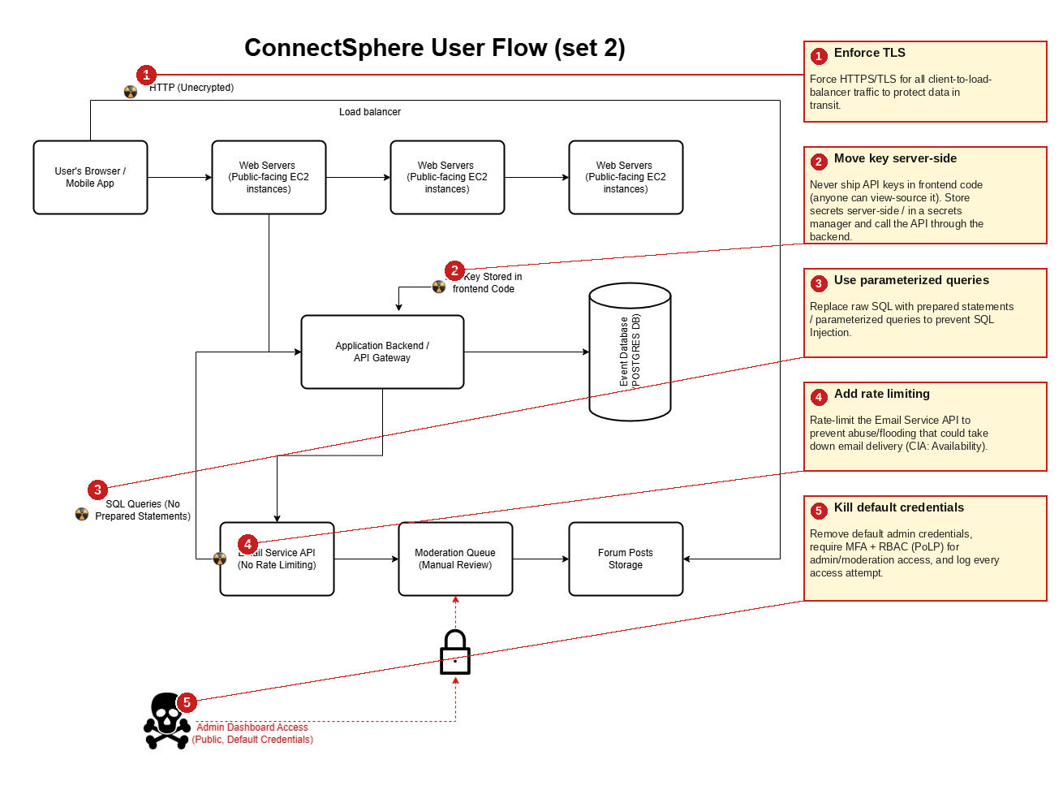
1. ① Enforce TLS — Force HTTPS/TLS for all client-to-load-balancer traffic to protect data in transit.
2. ② Move key server-side — Never ship API keys in frontend code. Store secrets server-side / in a secrets manager and call the API through the backend.
3. ③ Use parameterized queries — Replace raw SQL with prepared statements / parameterized queries to prevent SQL Injection.
4. ④ Add rate limiting — Rate-limit the Email Service API to prevent abuse or flooding that could take down email delivery (CIA: Availability).
5. ⑤ Kill default credentials — Remove default admin credentials, require MFA and RBAC (PoLP) for admin/moderation access, and log every access attempt.

Deliverable 3: Summary of Review Process
For Set 2, I traced each data flow — client to load balancer, backend to database, backend to the Email Service and Moderation Queue — and checked every hop against Confidentiality, Integrity, and Availability rather than only listing the flagged icons. Two issues stood out as compounding Confidentiality risks: unencrypted HTTP for all client traffic, and an API key hardcoded into frontend code, which is effectively a public credential since anyone can view a page's source. The missing prepared statements on backend SQL queries is a straightforward Integrity risk, and — specific to this set — the Email Service API's lack of rate limiting is an Availability risk that directly threatens the platform's own stated goal of "consistent availability for events."
The most severe finding is the publicly reachable admin dashboard secured only by default credentials — a textbook Principle of Least Privilege violation requiring essentially zero attacker effort. From a UI/UX specialization angle, this is a useful reminder that convenience decisions at the interface layer (an easily discoverable admin URL, credentials left at defaults for faster setup) create exactly the kind of exposed surface OSINT techniques are built to find.
Fixing these issues moves ConnectSphere meaningfully closer to GDPR/CCPA readiness, since both frameworks expect encryption of personal data and demonstrable access controls. The recommended monitoring metric — admin login attempts by outcome — gives the organization concrete, auditable evidence of access-control enforcement, supporting transparent, accountable governance rather than a one-time fix that's never verified again.

